**Verification Plan for IDVS Application**

**CHG0023469- IDVS Prod Deployment**

* Check - application is up & running.

As soon as we received the mail from the respective team, asking us to validate the application after the deployment activity is over, hit the production url on the browser.

**http://idvs.mas.net**

Login page will be visible for this app.

Now you can login and move forward with the verification of application.

Simultaneously capture the artifacts for proof.

* Artifacts:

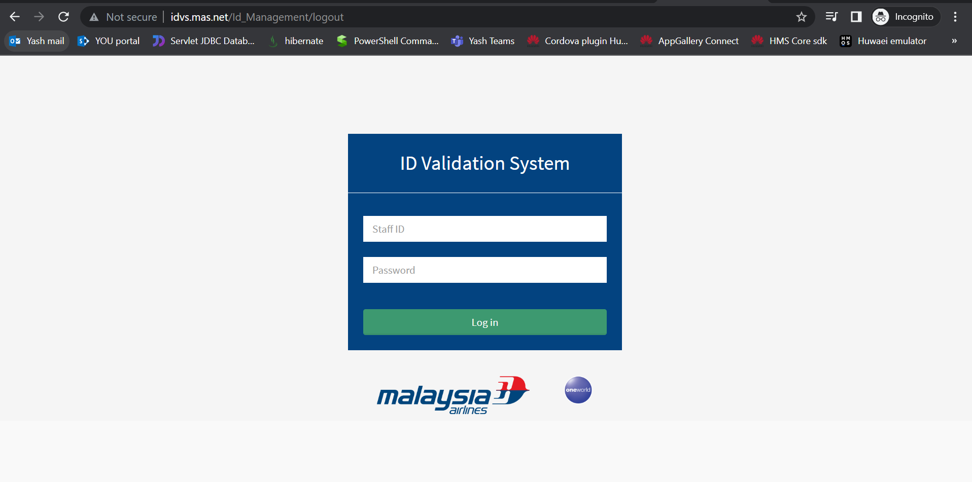

* Application Login is working fine.

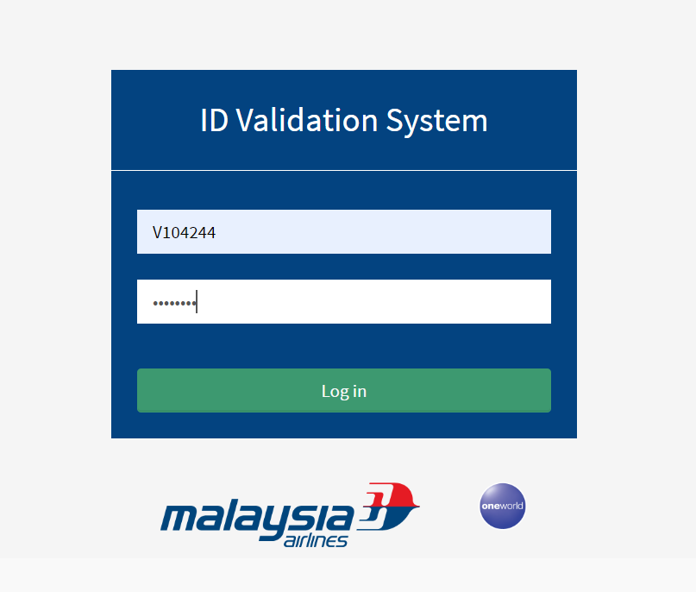

* Released functionality/Basic functionality.
* Home page - after login is successful

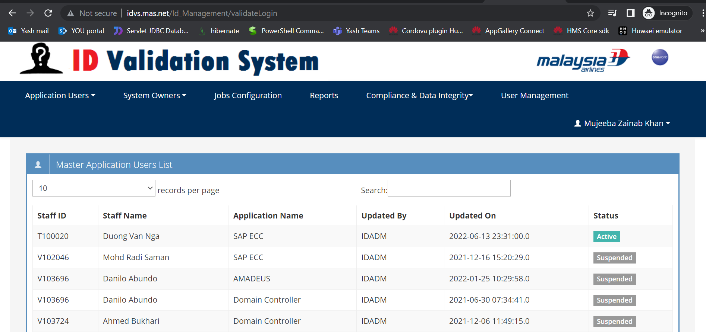

* Application System Owners List

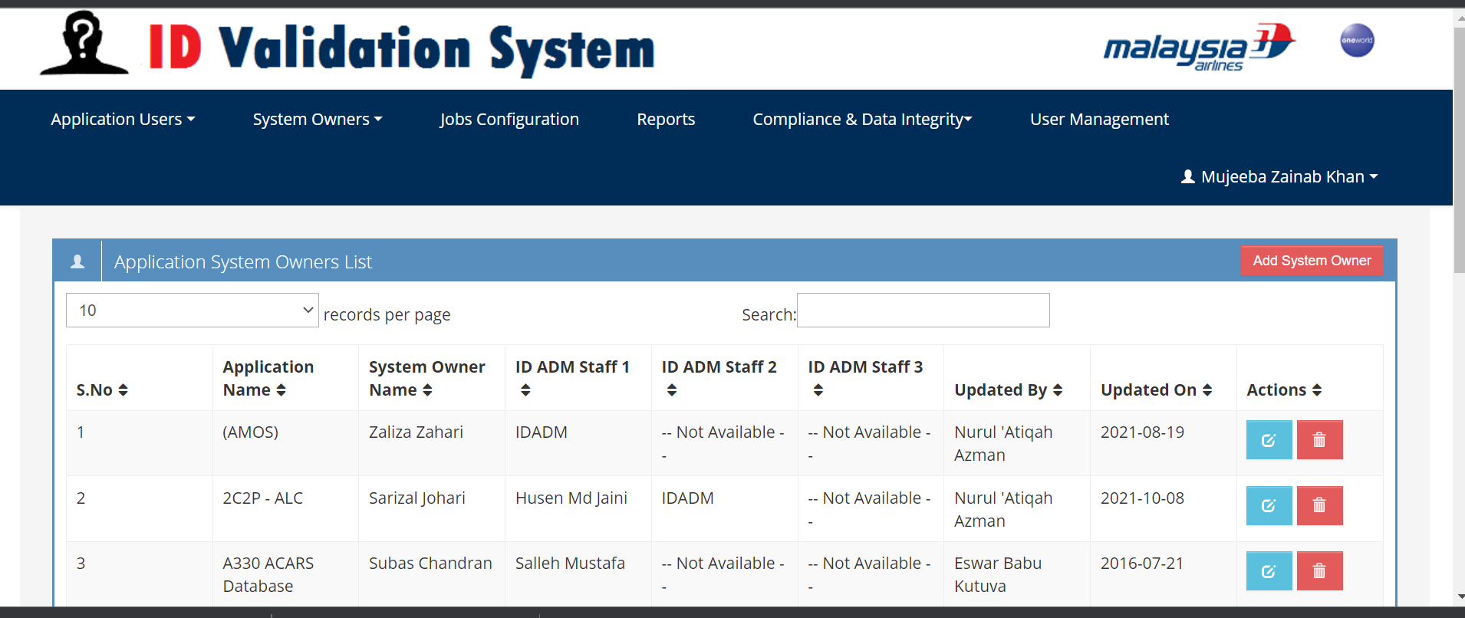

* User Management

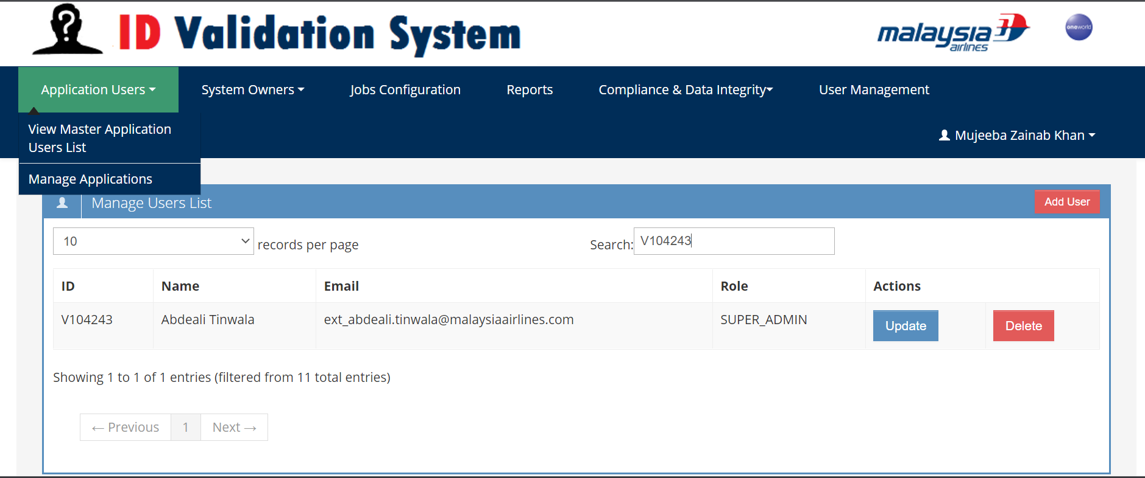

* Jobs Configuration

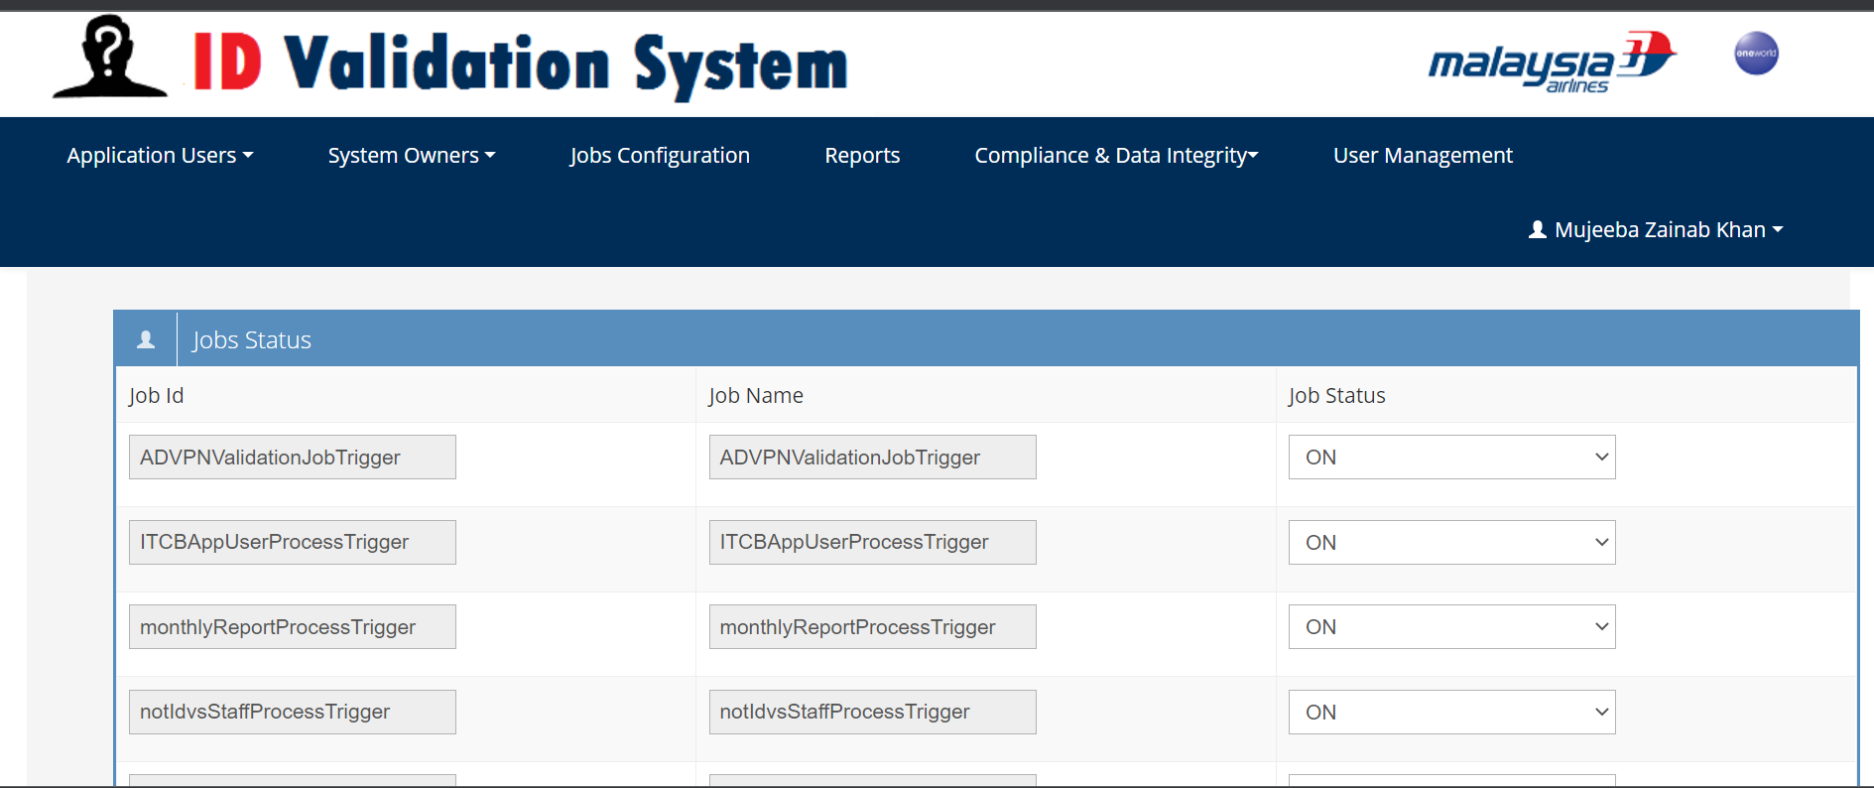

* Verify the log - Check for any unexpected error.

As you will be having the server access for this application – Check the logs with this

**ip-** 10.221.4.14

**logpath -** /tomcat/apache-tomcat/logs/IDVS_IDADM.log

